Engineering Specification - Production-Grade AI Personalized News Briefing System
Document Type: Engineering Spec (Build-Ready)
Owner: Ashish Jain (AI/ML Engineer)
Version: v1.0 (Draft for implementation)
Date: 13 Jan 2026
Project Codename: ai-news-briefing-system

0) Provenance, Scope Boundaries, and “No Hallucination” Contract

0.1 What this spec is based on (ground truth)
This specification is grounded in:
- Your project idea definition from the uploaded Ideas.pdf (news ingestion → preprocessing → embeddings + vector DB → retriever tool → agent decides retrieval → RAG summarization → memory update → deployment as chat + daily digest).
- The “production-grade, layered architecture” principles from Fareed Khan’s “7 layers” approach: modular codebase, settings management, persistence, security safeguards, resilient service layer, stateful multi-agent orchestration (LangGraph + checkpointing), API gateway, observability and evaluation.

0.2 No hallucination / ambiguity rules for this spec
- No claim is presented as a fact unless it is either:
  - explicitly required by your plan, or
  - explicitly described in the referenced sources above.
- Any implementation choice not fixed by your plan is labeled Decision Required or Option.

0.3 Objective
Build a resilient end-to-end agentic AI system that delivers personalized daily news briefings and interactive Q&A over ingested articles with:
- mandatory grounding (citations),
- security hardening against prompt injection,
- token/cost optimization,
- comprehensive evaluation and observability,
consistent with a “production-grade layered system” philosophy.

1) Product Definition

1.1 User stories
- Daily Briefing: As a user, I receive a concise daily digest focused on my interests (topics + preferences), with citations to source articles.
- Interactive Q\&A: As a user, I can ask “What are the latest developments in X?” and receive a synthesis grounded in recently ingested news, with citations.
- Personalization: As a user, the system learns from my feedback (like/dislike/save) to refine future briefings.
- Safety: As an operator, I can trust the system to avoid ungrounded claims and resist prompt-injection attempts from user input or retrieved articles.
- Operability: As an operator, I can monitor latency, error rates, token spend, grounding pass/fail rate, and retrieval quality.

1.2 Non-goals (v1)
- Full “web browsing” or arbitrary web scraping (beyond configured RSS/News API sources).
- Financial advice, political persuasion, or other high-risk content generation.
- Real-time “breaking news” guarantees (depends on ingestion schedule and sources).

2) Requirements

2.1 Functional requirements (FR)
FR-1 Ingestion
- Periodically ingest articles from RSS feeds and/or a News API (config-driven).
- Deduplicate by URL hash; store raw + normalized text.
FR-2 Indexing
- Chunk, embed, and store article chunks in a vector store (e.g., Chroma/Pinecone).
FR-3 Retrieval
- Implement a retriever tool that returns top-K relevant chunks with metadata (url/title/source/published_at).
FR-4 Agentic Q\&A
- Agent decides whether to retrieve or answer directly; when retrieval is required, it must use retriever tool.
- Responses must include citations when factual claims are made.
FR-5 Daily Briefing
- Generate a daily digest for each user using:
  - user profile memory (explicit topics + learned preferences),
  - retrieval over recent news window,
  - synthesis with citations.
FR-6 Memory Update
- Store user feedback and update long-term profile memory for personalization.
FR-7 API/UX
- Provide API endpoints for chat, feedback, and daily briefing delivery (email/markdown). (Delivery channel is a decision.)

2.2 Non-functional requirements (NFR)
- NFR-1 Groundedness: “No citation → no factual answer.”
- NFR-2 Resilience: retries + backoff for external calls; circuit breakers; graceful degradation (fallback model or partial response).
- NFR-3 Security: sanitize inputs and retrieved text; detect prompt injection patterns; enforce strict schema output.
- NFR-4 Cost control: token budgeting; dynamic retrieval K; caching for embeddings & repeated queries.
- NFR-5 Observability: tracing, structured logs with request IDs, metrics for grounding pass rate and token spend.
- NFR-6 Testability: unit + integration + adversarial tests; evaluation harness with regression gates.

3) Key Decisions (to be locked; defaults provided)

3.1 Decisions required
- Deployment posture: Personal-only vs SaaS-style (auth, multi-user).
- Ingestion sources: RSS-only (simpler) vs RSS + News API.
- Vector store: local (Chroma) vs managed (Pinecone).
- Delivery channel: email digest vs web UI vs Teams/Slack bot.

3.2 Default choices for v1 (recommended)
- RSS-first ingestion (lowest friction); optionally add News API adapter later.
- Chroma local for development; keep adapter interface so Pinecone can be swapped later.
- API + markdown digest output (email integration optional).
- Auth optional: implement minimal API key / token guard even for personal use to align with production patterns.
These defaults are not “facts”; they are recommended implementation choices consistent with your plan and the production-grade layering approach.

4) Architecture Overview (Layered, Production-Grade)
This system follows a layered architecture consistent with “production-grade agentic systems” principles: modular separation, persistence, safeguards, resilient services, stateful orchestration, API gateway, and observability/evaluation.

4.1 High-level architecture diagram
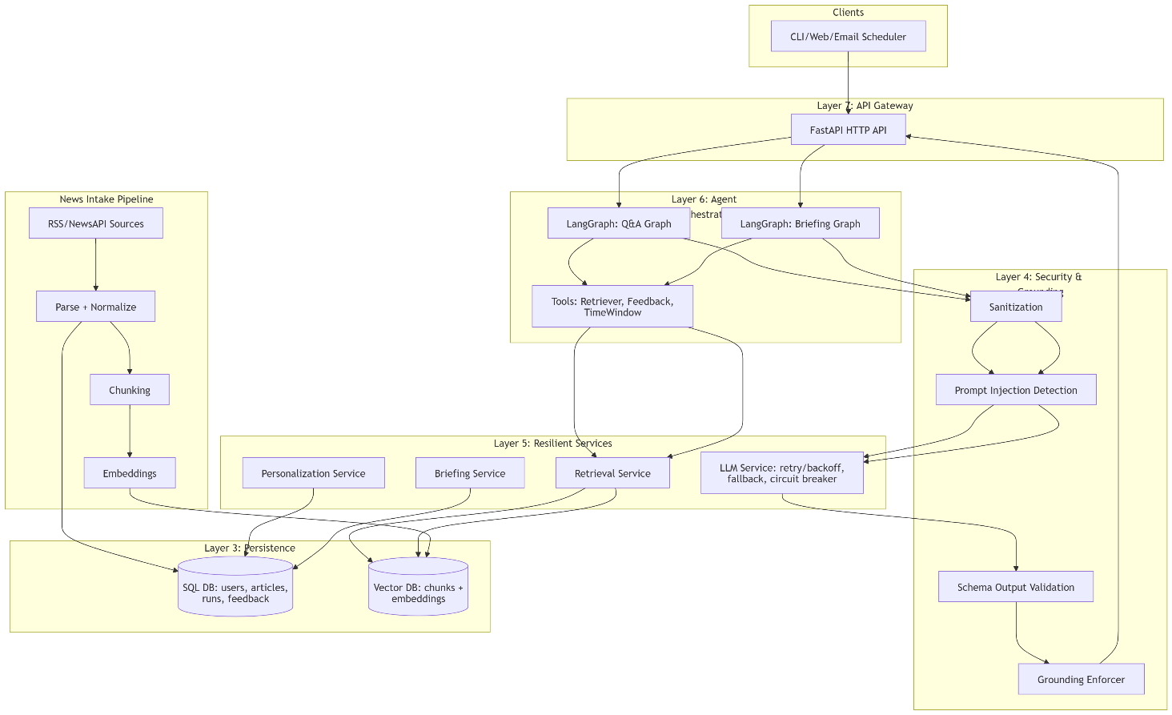Notes:
- The idea’s required pipeline stages (intake, preprocessing, embedding/index, retriever tool, agent interaction, summarization, memory update, deployment) are explicitly represented.
- Resilience, safeguards, observability are drawn from the “production-grade layers” framing.

5) Data Model & Persistence

5.1 Relational entities (SQL)
User
- user_id (UUID or int)
- email (optional if SaaS)
- created_at
UserProfile
- user_id
- explicit_topics (array/string JSON)
- blocked_topics (array)
- interest_embedding_ref (pointer/ID if stored in vector store)
- preferences (JSON: briefing_length, tone, time_window_days)
Article
- article_id (sha256(url))
- url, title, source, published_at
- raw_text, clean_text
- ingested_at
- content_hash (for change detection)
Chunk
- chunk_id
- article_id
- chunk_text
- metadata_json (url/title/source/published_at)
FeedbackEvent
- event_id
- user_id
- article_id (optional)
- signal (like/dislike/save/skip)
- timestamp
- comment (optional)
BriefingRun
- run_id
- user_id
- date
- status (success/fail)
- citations (array)
- token_usage (json)
- latency_ms
- grounding_pass (bool)
AgentThread
- thread_id
- user_id
- created_at
- last_state_checkpoint_ref (if LangGraph checkpointing)

5.2 Vector store collections
- news_chunks: embeddings of chunked article content
- (Optional) user_memory: embeddings representing user interests / topics / feedback summaries

5.3 Idempotency & dedup
- Primary dedup key: article_id = sha256(url)
- Re-ingestion should:
  - skip if article_id already exists and content_hash unchanged
  - upsert if content changed (rare for news, but possible)

6) Core Workflows

6.1 Ingestion workflow (scheduled)
Trigger: Cron / scheduler (e.g., every 30–60 minutes)
- Fetch source feed payload(s)
- Parse items → normalize fields
- Validate source authenticity / allowlist domain
- Sanitize content (remove scripts, collapse whitespace, enforce max size)
- Dedup by URL hash
- Chunk clean text
- Embed in batches
- Upsert chunks into vector DB with metadata
- Persist article metadata in SQL
- Emit metrics/logs for ingestion success/failure

6.2 Q\&A workflow (agentic)
Trigger: POST /api/v1/chat/query
State machine nodes (LangGraph-ready):
- LoadProfile
- SanitizeInput
- DecideRetrieve (agent decides retrieval vs direct)
- RetrieveTopK (retriever tool)
- SynthesizeAnswer
- ValidateSchema
- GroundingCheck (citations required)
- UpdateMemoryAsync (feedback or implicit signals)
- Respond

6.3 Daily briefing workflow
Trigger: scheduler or POST /api/v1/briefing/generate
- Load profile (topics, blocked topics, preferences)
- Determine time window (default last 24h; configurable)
- Retrieve per-topic clusters + top headlines relevant to user
- Deduplicate sources
- Synthesize briefing (structured output + citations)
- Validate schema + grounding
- Persist briefing run + metrics
- Deliver output (markdown/email)

7) Agent Orchestration Design (LangGraph patterns)
The production-grade reference emphasizes stateful orchestration, checkpointing, memory integration, and tool calling for reliability.

7.1 Agent state definition (typed)
AgentState fields (Pydantic or TypedDict)
- request_id
- user_id
- mode (qa | briefing)
- query (for QA)
- profile (snapshot)
- retrieval_needed (bool)
- retrieved_chunks (list[ChunkRef])
- draft_output
- citations (list[url])
- grounding_pass (bool)
- token_budget (inputs/outputs)
- errors (typed error objects)

7.2 Tools (first-class)
- retriever_tool(query, filters, k) -> List[ChunkRef]
- feedback_tool(user_id, signal, article_id) -> Ack
- time_window_tool(preference) -> {from,to}

7.3 Checkpointing (optional but recommended)
- Persist agent thread state for replay/debug and crash recovery (aligned with “state persistence / checkpointing” emphasis).

8) Safety, Grounding & Hallucination Prevention
The project idea requires RAG grounding, and your plan requires mandatory citations + verification.

8.1 Mandatory grounding contract
- If output contains factual assertions:
  - Must include citations (URL/source IDs) corresponding to retrieved chunks
  - Must not cite sources outside retrieval set
- If retrieval context is insufficient:
  - Return a safe response: request clarification or broaden sources/time window

8.2 Grounding checker (two-stage)
Stage A: Rule-based
- citations exist
- each citation maps to retrieved metadata
- time window constraints satisfied
Stage B: Model-assisted verification (optional)
- Compare claims to context; remove unsupported claims
- Produce a confidence_score and allow output only above threshold

8.3 Output schema enforcement
- All briefings and structured Q\&A must conform to JSON schema (and Pydantic model validation).
- If schema validation fails:
  - retry with stricter constraints
  - fall back to simpler schema
  - final fallback: return cached last-good response (if exists)

9) Security Hardening
The production-grade reference explicitly includes rate limiting and sanitization as a dedicated security layer.

9.1 Threat model (v1)
- Indirect prompt injection via article content
- Prompt injection via user input
- Malicious RSS feed poisoning
- Denial-of-wallet/token abuse via long inputs
- Data exfil attempts via prompts

9.2 Controls
Input controls
- Character set restriction
- Max length limits (user query, topics, article text)
- URL allowlist for RSS domains (config)
Content sanitization
- Strip HTML/JS
- Normalize whitespace
- Remove non-printing characters
- Truncate overly long articles
Prompt injection detection
- Pattern checks for “ignore previous instructions”, “system prompt”, etc.
- Treat retrieved content as untrusted and never allow it to override system instructions
Rate limiting
- Endpoint-level limits:
  - chat
  - streaming chat
  - briefing generation
  - ingestion trigger
- Require admin key for ingestion triggers in non-dev

10) Reliability & Resilience
The production-grade reference highlights retries, circuit breakers, model fallback, and connection pooling for reliability.

10.1 Error taxonomy (typed)
Define typed exceptions (examples):
- RateLimitError
- APIConnectionError
- TokenLimitError
- VectorStoreError
- SchemaValidationError
- GroundingViolationError
- PromptInjectionDetectedError

10.2 Retry policy
- External calls (LLM, ingestion source, embeddings):
  - exponential backoff
  - max attempts configurable per endpoint

10.3 Circuit breaker policy
- Trip breaker on:
  - high error ratio
  - repeated timeouts
- While open:
  - return cached results if available
  - degrade gracefully (e.g., “briefing unavailable; try later”)

10.4 Model fallback
- If primary model fails (timeouts/429):
  - fall back to a smaller/cheaper model
- Track fallback rate as a metric (signals cost/availability issues)

11) Token & Cost Optimization

11.1 Token budgeting
- Compute token estimates for:
  - user query
  - retrieved context
  - system prompts
  - expected output size
- Enforce budgets:
  - shrink K
  - compress context (summary pass)
  - shorten output format

11.2 Retrieval optimization
- Dynamic K based on query complexity:
  - simple question → small K
  - broad multi-topic query → larger K
- Enforce recency filters for “latest developments” queries

11.3 Caching
- Cache embeddings for identical chunks (content-hash)
- Cache common queries (TTL)
- Cache daily briefings per user per date

12) Evaluation Framework (Offline + Regression Gates)
The production-grade reference includes LLM-as-a-judge style evaluation and operational testing emphasis.

12.1 Datasets
- evals/datasets/:
  - curated RSS snapshot dataset
  - query set (50–200)
  - reference briefings (human written or baseline system output)

12.2 Metrics
Retrieval
- precision\@K
- NDCG
- coverage by topic
Generation
- structure correctness (schema validity rate)
- citation coverage (#citations / #claims)
- groundedness pass rate
Safety
- prompt injection resistance score (adversarial suite)
Latency/Cost
- tokens per request
- latency percentiles (p50/p95)
- fallback frequency

12.3 Regression gates
Block release if:
- grounding pass rate drops below threshold
- schema validity rate drops
- token cost per request increases beyond threshold
- injection test suite fails

13) Observability & Monitoring
The production-grade reference emphasizes logging/tracing/metrics and monitoring.

13.1 Structured logging (required)
Log fields:
- request_id
- endpoint
- user_id (hashed)
- retrieval_k
- citations_count
- token_in/token_out (if available)
- latency_ms
- grounding_pass
- error_type

13.2 Tracing (recommended)
Trace spans:
- ingestion
- retrieval
- LLM call
- grounding check
- schema validation
- memory update

13.3 Metrics dashboard (recommended)
- ingestion success rate
- retrieval empty rate
- grounding failures
- token spend per endpoint
- latency histograms
- fallback model usage

14) API Specification (v1)
Base path: /api/v1

14.1 POST /chat/query
Request
{
"userid": "string",
"query": "string",
"timewindow_days": 3,
"stream": false
}
Response
{
"answer": "string (markdown)",
"citations": ["https://…"],
"usedarticles": ["articleid"],
"groundingpass": true,
"requestid": "uuid"
}

14.2 POST /briefing/generate
Request
{
"userid": "string",
"date": "YYYY-MM-DD",
"timewindow_hours": 24
}
Response
{
"briefingmarkdown": "string",
"citations": ["https://…"],
"groundingpass": true,
"request_id": "uuid"
}

14.3 POST /users/{user_id}/profile
Request
{
"explicittopics": ["AI", "aviation", "renewables"],
"blockedtopics": ["celebrity gossip"],
"preferences": {
"briefinglength": "short|medium|long",
"timewindow_days": 3
}
}
``

14.4 POST /users/{user_id}/feedback
Request
{
"signal": "like|dislike|save|skip",
"article_id": "sha256(url)",
"comment": "optional"
}

14.5 POST /admin/ingestion/run (optional / protected)
Triggers ingestion on-demand.

15) Project Structure (Build Artifact)
Use the repo structure defined in Section 2, with each directory mapping to a layer:
- system/ = settings/logging/middleware (Layer 2)
- persistence/ = SQL + vector adapters (Layer 3)
- safety/ = sanitization + grounding + injection defense (Layer 4)
- services/ = resilience patterns (Layer 5)
- agent/ = LangGraph graphs + tools + memory (Layer 6)
- api/ = gateway endpoints (Layer 7)
- evals/ + observability/ = evaluation and monitoring (production-grade emphasis)

16) Implementation Plan (Milestones)

Milestone 0 — Scaffolding (Days 1–2)
- Repo structure + Settings + logging + error taxonomy
- Pydantic models & DTOs

Milestone 1 — Ingestion + Index (Days 3–7)
- RSS ingestion + parser + dedup
- Chunking + embeddings + vector upsert
- Store article metadata in SQL

Milestone 2 — Retrieval + Grounded Q\&A (Days 8–12)
- Retriever tool
- Q\&A pipeline with schema + grounding enforcement

Milestone 3 — Personalization + Daily Briefing (Days 13–18)
- User profile memory + feedback loop
- Daily digest generation + citations

Milestone 4 — Security + Resilience (Days 19–23)
- sanitization + injection tests
- rate limits
- retry/backoff + circuit breaker + fallback

Milestone 5 — Evaluation + Observability (Days 24–30)
- offline eval harness + regression gates
- dashboards/metrics + traces

17) Runbook (Operational)

17.1 Local dev
- Start SQL + vector store
- Run ingestion
- Validate retrieval with sample queries
- Generate briefing for test profile

17.2 Failure modes & responses
- LLM 429/timeouts: trigger backoff; fallback model; return partial if needed
- Vector store down: return “cannot retrieve sources”; refuse factual answers
- Ingestion fails: continue with other feeds; alert via logs/metrics
- Schema failures: retry; fallback schema; return cached last-good output

18) Appendix — How this spec aligns with your source materials
- The end-to-end pipeline and features (RAG, ingestion, vector DB, daily briefings, user memory) directly match the “Personalized News Briefing Agent” description in your ideas document.
- The layered approach (modularity, safeguards, resilience, API gateway, observability, evaluation) aligns with the “production-grade agentic system” framing and the associated implementation blueprint described in the 7-layer guide.

Next Step (so we lock this spec into “build mode”)
Reply with your choices for the 4 “Decision Required” items (Section 3.1).\ Once you do, I will produce the Implementation Checklist + exact file-level stubs (function signatures, class names, module responsibilities) in a way that you can execute day-by-day without ambiguity—while preserving your “no hallucination” requirement.

